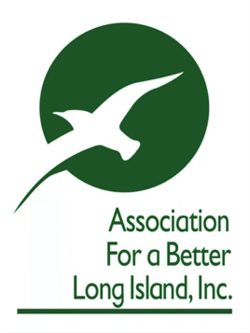

From: Association for a Better Long Island
Date: February 5, 2022
Contact: Rubenstein
__________Gary Lewi 516 316-0579 glewi@rubenstein.com

For Immediate Release

ABLI confronts L.I. school districts
now flush with COVID cash

“No school tax increases must become a state directive”

(Hauppauge, N.Y.) - Stating that the huge cash windfall for Long Island school districts must translate into an immediate freeze on school tax increases, the Association for a Better Long Island (ABLI) is proposing that Albany amend current funding formulas so that school districts are rewarded for financial discipline.

ABLI’s executive director Kyle Strober said, “New York State is prepared to send over $4 billion dollars to Long Island schools during the 2022-23 academic year. The idea that any district would then turn around and seek a property tax increase, or place those dollars in their reserve fund, is somewhere between incomprehensible and despicable.”

In a letter to Governor Kathy Hochul and State Comptroller Thomas DiNapoli, the ABLI notes, “The federal government delivered $8.9B in funding to NYS schools and Long Island will receive nearly $324M. Last year’s state budget allocated $417M for Long Island schools and this year’s proposed budget increases aid for public schools by $2.1B or 7.1% to a total of $31.2B for the 2022-23 fiscal year.

“Considering the record amount of funding from the state & federal government, combined with LI school reserve funds amounting to $2.61B in 2020-21, it would be unconscionable for our region’s schools to raise taxes and thereby further adding to the pandemic burden placed on our residents,” continued Strober.

Tax increases are shunted into “reserve funds”

Strober reminded that what is particularly disturbing is data from a NYS Department of Education report that revealed the total reserves accumulated by the 120-plus Long Island school districts have ballooned to $2.61 billion in 2020-21. The average district cash holdings equal nearly 20% of the schools’ projected spending.

“Long Island school districts have been amassing small fortunes on the backs of taxpayers in case of a `rainy day.’ They have repeatedly incurred the criticism of the State Comptroller who, beyond his thorough audits, is not empowered to penalize those districts,” Strober stated.

Between the enormous windfall coming to school districts and an accumulation of “reserve funds” that far outstrip their needs, the ABLI believes it critical that NYS pass legislation and/or amend current NYS Department of Education funding formulas that incentivize school districts that put forth no tax increase budgets. Providing additional funding to school districts who hold the line on taxes, and stay within the NYS 4% reserve fund limit, will dramatically help reduce the current tax burden and help generate additional economic activity on Long Island.

The ABLI is a leading regional economic development organization whose membership is collectively Long Island's largest property taxpayer.

​

