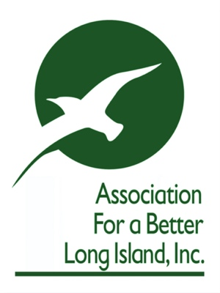

June 2, 2020

Ms. Megan J Brennan
Postmaster General
United State Postal Service
475 L’Enfant Plaza SW
Washington, D.C. 20260

Re: Face masks for USPS Mail Carriers
Dear Postmaster General Brennan:
I respectfully write your office on behalf of the Association for a Better Long Island (“ABLI”) to request that the United States Postal Service (“USPS”) require its letter carriers to wear face masks who deliver to and/or within commercial and industrial buildings.
ABLI consists of the largest commercial, industrial and/or mixed-use property owners in a region of 2.7 million people, representing more than 40 million square feet of commercial & industrial space. In response to the COVID-19 pandemic, our members are going to great lengths to ensure the safety of its tenants, employees & visitors and reduce the potential spread of the virus. They are implementing the most stringent CDC protocols, one in particular is that anyone who enters a building must wear a face mask. (New York State Executive Order 202.34, legally allows a business or property owner to deny admittance of individuals not wearing a mask.)
Last week, a USPS letter carrier refused to wear a mask while delivering mail at a commercial office building located at 3000 Marcus Ave, Lake Success. Upon entrance to the building, the security officer requested the letter carrier to wear a face mask. The letter carrier responded, “I’m not delivering the mail if I have to wear a mask.”

The building in question is approximately 130,000 square feet with approximately thirty independent tenants, consisting mostly of professional services such as accounting and law firms. The letter carrier’s refusal to wear a face mask puts the health of that building’s employees, tenants and visitors at risk. There is little doubt it is an action repeated throughout his daily appointed rounds.

In order to reduce the spread of COVID-19, our organization believes it imperative that the USPS require all its letter carriers who deliver to and/or within commercial and industrial buildings wear face masks. There is more than a small amount of irony that USPS currently requires customers to wear face masks in its post offices yet the agency does not require its letter carriers to wear face masks when entering places of work along their route.

To ensure the safety of all concerned, and in accordance with current CDC guidelines, the ABLI respectfully requests that the USPS instruct its letter carriers to wear face masks when delivering mail within commercial and industrial buildings.
Sincerely,
_____________________
Kyle Strober, Executive Director
Association for a Better Long Island

cc: U.S. Senator Charles E. Schumer
U.S. Senator Kirsten E. Gillibrand
U.S. House of Representatives Long Island Delegation

